1. Final Group Project Report (Due Dec 1st)

The report should be clear, concise and complete.

Every sentence in the report should be there for a purpose.

A template is given below:

Title Page

Executive Summary

Table of Contents

List of Figures

List of Tables

Terms, Acronyms, and Abbreviations

1. Introduction

1.1. Purpose and Scope

1.2. Product Overview (including capabilities, scenarios for using the product, etc.)

1.3. Structure of the Document

2. Project Management Plan

2.1. Project Organization

2.2. Lifecycle Model Used

2.3. Risk Analysis (optional)

2.4. Hardware and Software Resource Requirements (also describe what new software or hardware features each team member learned during the project)

2.5. WBS, Deliverables and Schedule

2.6. Monitoring, Reporting, and Controlling Mechanisms

3. Requirement Specifications

3.1. Stakeholders for the system

Ayman Ibrahim, Zack Munford and Kierra McCallum

Customers interested in services by Meezy Cutz

Consumers interested in Meezy Cutz apparel

3.2. Use case model

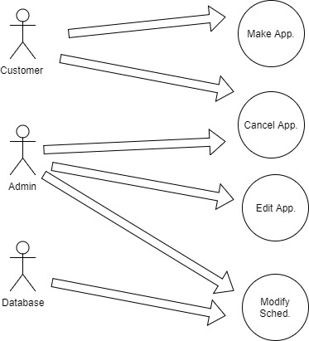

3.2.2. Textual Description for each use case

Within the website, there will be four different use-cases and three different uses. The uses will be the consumer, admin and database.

3.3. Rationale for your use case model

The use case model shows the relationship between the uses and the use-cases. The uses were consumer, admin, and database. The purpose of using these three uses was to present the three main uses that will be used when accessing the website. The use cases were make appointment, cancel appointment, cancel appointment, and modify appointment. The purpose of using these use-cases were to present the different things consumers can access on the scheduling system. The use-cases also show which uses relate to specific use-cases.

3.4. Non-functional requirements

The website’s non-functional requirements of performance, availability, reliability, maintainability and serviceability are all components that will be met. The performance of the website will be dependent on the Internet connection of the consumer. The availability of the website will be at 99% besides the maintenance hours that will be implemented. Reliability of the website will be at a high percentage due to the website staying steady with performance without crashing or other issues. Maintainability of the website will also be at a high level due to the developers keeping up with the website constantly to provide high performance for consumers. Service on the website will be kept up to date due to the developers keeping a high level of priority to maintain quality service to consumers.

4. Architecture

4.1. Architectural Design

4.2. Technology, software, and hardware used

4.3. Rationale for your architectural design

5. Design

5.1. GUI (Graphical User Interface) design

5.2. Static model – class diagrams

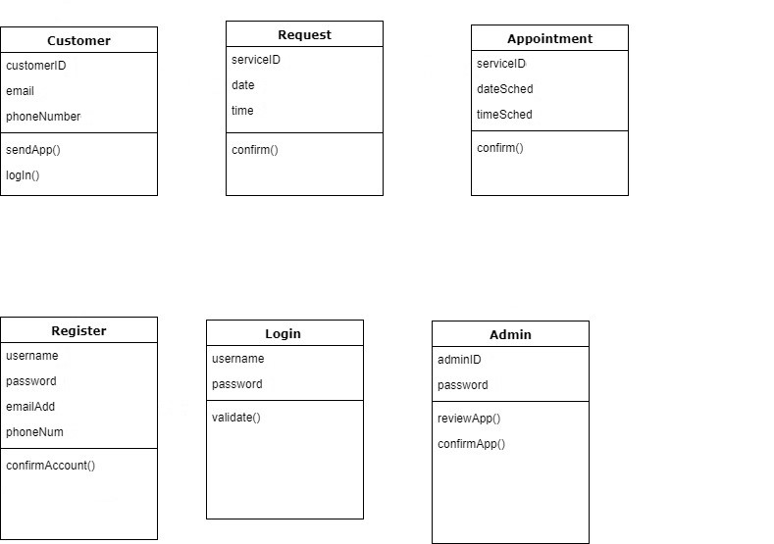

5.3. Dynamic model – DFD and/or sequence diagrams 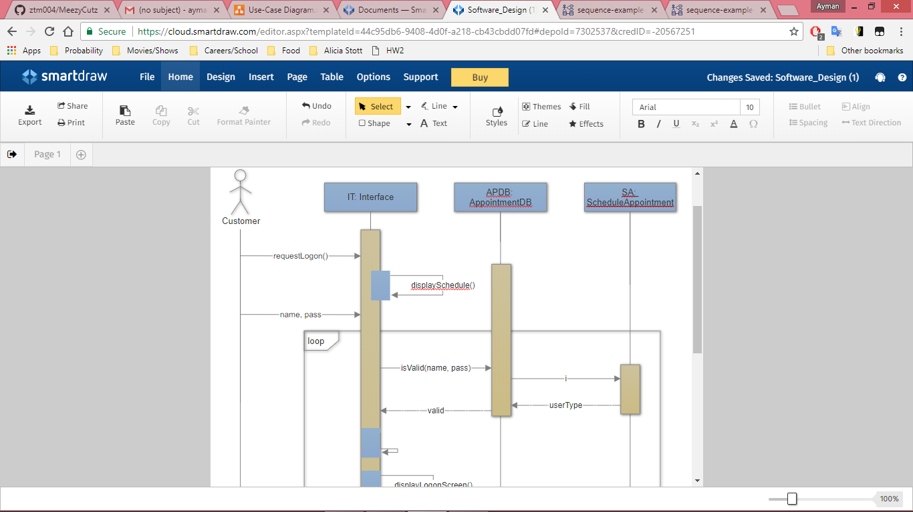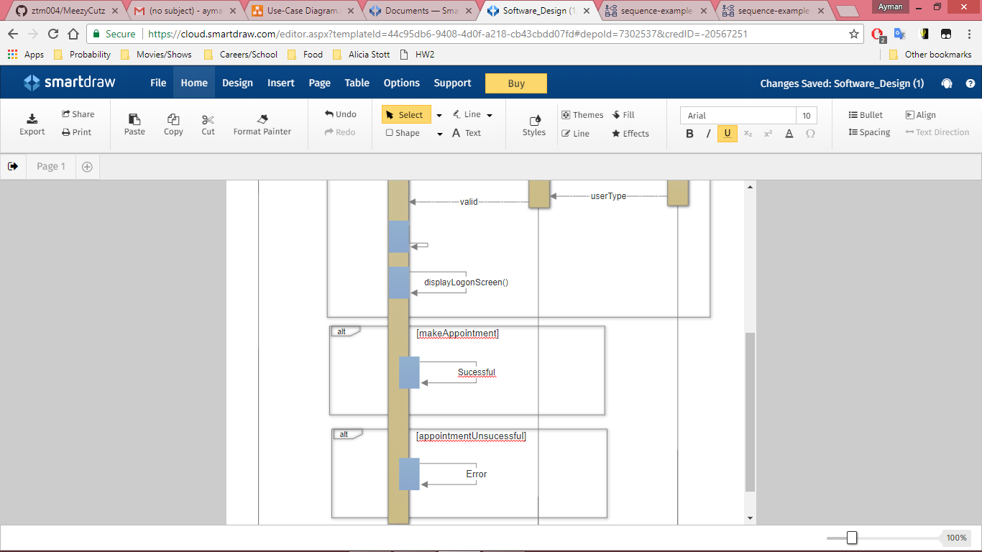

5.4. ERD, Database design

Third-Party database used for website.

5.4. Rationale for your detailed design model

The rationale for the design model was based on the prototyping that was done before implementing the website. When implementing, we targeted an appealing website design that would attract consumers into visiting the site and potentially become a customer in the near future.

6. Test Plan

6.1. Requirements/specifications-based system level test cases

6.2. Class/ Unit test cases

6.3. Traceability of test cases to use cases

6.4. Integration Plan

6.5 Techniques used for test generation (if any)

7. User Manual

Appendix A: Screen shots

Appendix B: Code

1. Final Presentation Slides (Dec 6th) [ Presentation is on Dec 8th 10:45 am]

Include at least one slide for each of the following topic.

1. Topic Heading and Team members
2. Project Introduction
3. Your Approach (Lifecycle Model you used)
4. Major Requirements
5. Acceptance Test Cases
6. Architecture Design
7. Class Diagram
8. Major Operations
9. Unit test cases & results
10. GUI design
11. Database design
12. Acceptance Test Case Results
13. Future Enhancement

You also need to demonstrate your final product.

1. Individual report (Due Dec 6th)

Include at least the following:

What is your contribution to the project? Also explain other team members’ contributions.

Are you satisfied with your contribution to the project? If not you may explain why, and also describe how you will do it differently next time if you were given another opportunity.

What did you learn in this project?

Briefly explain one think that you like about this project, and one thing you don’t like.

Any other comments or concerns.

1. Individual Presentation (Due Dec 6th) {Presentation is on Dec 8th !0:45 am]

At least 3 slides:

1. Overall project – your view
2. Your Contribution
3. What did you learn from this project
4. Any other
5. Peer Review (group- on other groups) [Due on Dec 6th]

Guidelines:

You are just checking whether each section is clearly, concisely and completely described in the project report.

|  |  |  |
| --- | --- | --- |
| GROUP NAME: | | |
| Sections | Points (0-10) | Rational (why did you give this point?) |
| Project Descriptions& Scope |  |  |
| Group’s Approach |  |  |
| Major Requirements |  |  |
| Architecture Design |  |  |
| Static Design – Class Diagram |  |  |
| Dynamic Design |  |  |
| Database Design |  |  |
| GUI Design |  |  |
| Test Design & Report |  |  |
| User Manual |  |  |
| Demonstration |  |  |